|  |  |
| --- | --- |
| C:\Users\logon\Desktop\download.jfif | DEPARTMENT OF INFORMATION TECHNOLOGY |

|  |  |
| --- | --- |
| Subject: Wireless and mobile Network (WMN) | Subject Code: 22622 |
| Semester: 6th | Course: IF6IA |
| Laboratory No: | Name of Subject Teacher: Kalyani Pawar |
| Name of Student: Yash Rajendra Hajare | Roll Id: 18202A0024 |

|  |  |
| --- | --- |
| Experiment No: | 8 |
| Title of Experiment | Simulate the Binary amplitude shift keying using MATLAB and Simulink. |

* **Aim:**

Simulate the Binary amplitude shift keying using MATLAB and Simulink.

* **Practical Significance:**

Amplitude shift keying (ASK) is type of digital modulation that represents digital data as variations in the amplitude of a carrier wave. The amplitude of an analog carrier signal varies in accordance with the bit stream (modulating signal) where frequency and phase are keeping constant. This practical is designed to explain how change of amplitude in to level corresponds to logic 1 and logic 0.ASK is a type of Amplitude Modulation which represents the binary data in the form of variations in the amplitude of a signal. Any modulated signal has a high frequency carrier. The binary signal when ASK modulated ,gives a zero value for low input while it gives the carrier output for high input.

* **Minimum Theoretical Background**



**Figure 1: ASK Input Output**



**Figure 2: ASK Input Output Waveforms**

**Practical Circuit Diagram (Sample Block Diagram)**



**Figure 3: ASK modulator**



**Figure 4: ASK demodulator**



**Figure 5: Waveforms of Carrier signal, Data signal & ASK wave**

* **Procedure:**
* **For Practical set up Circuit Diagram**

a. Make the connection as per circuit diagram.

b. Switch ON the power supply.

c. Connect digital input signal 1010110 on to the trainer kit of ASK modulator.

d. Observe the output of ASK modulator on CRO.

e. Connect output of ASK modulator to input of ASK demodulator.

f. Observe the output of ASK demodulator.

g. Draw the waveform on graph showing digital input signal, carrier signal, modulated signal and demodulated signal.

h. After completion of practical switch off the supply, remove the connection and submit the wires and equipments.

* **For Simulation**

a. Switch on the computer and click on the MATLAB icon.

b. Go to start at the bottom of the command window, then select “simulink” then go to library browser and drag it into creating file.(or) Once you open the MATLAB then click on simulink icon .Go to file and select new and then select model. You will get a new window.

c. Arrange the functional blocks as shown in simulink model.

d. Assign required parameters to each functional block.

e. Observe the outputs on scope.

* **Simulink Model of Amplitude Shift Keying Technique**



* **Simulation Output**



## **Practical related Questions**

1. Observe the ASK output for bit stream 1100101

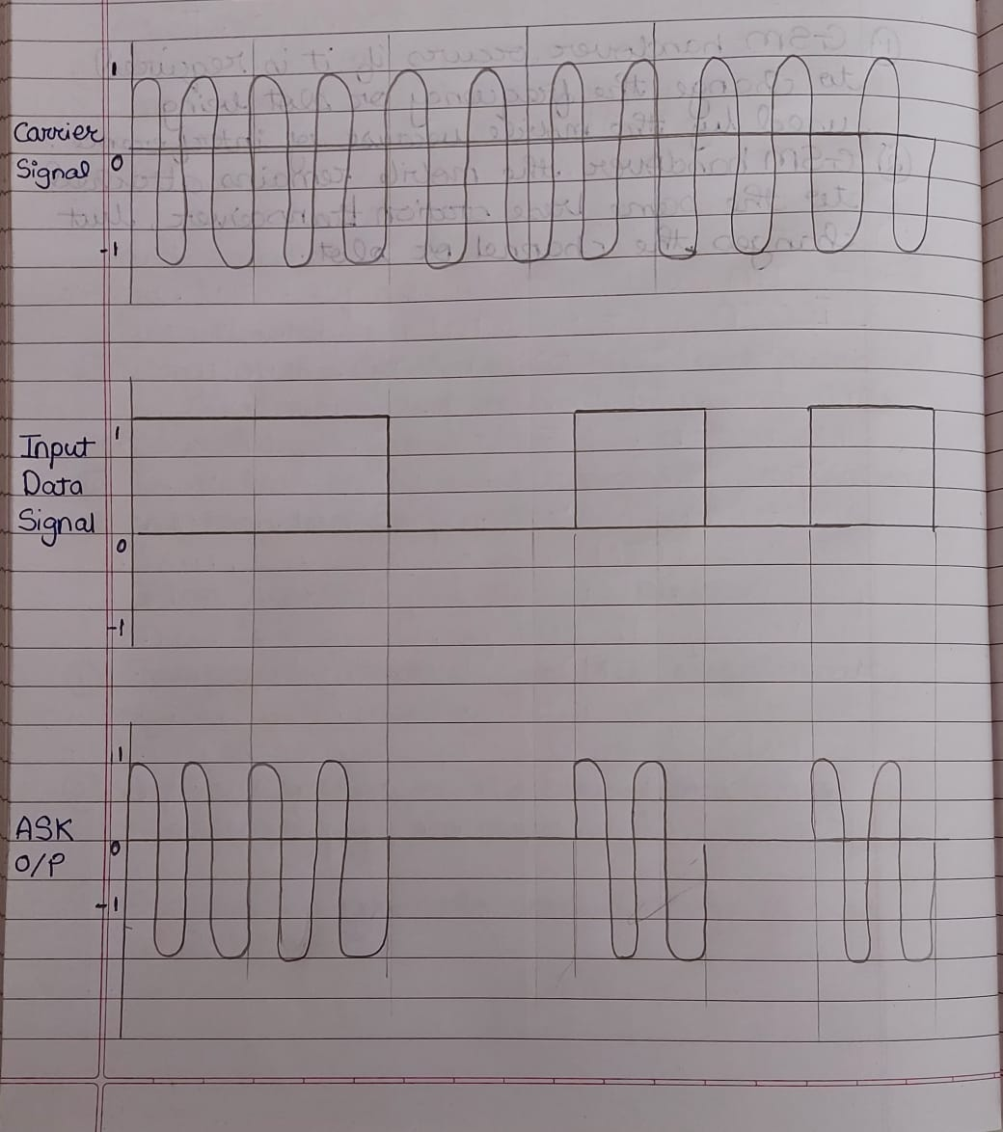Ans-

1. 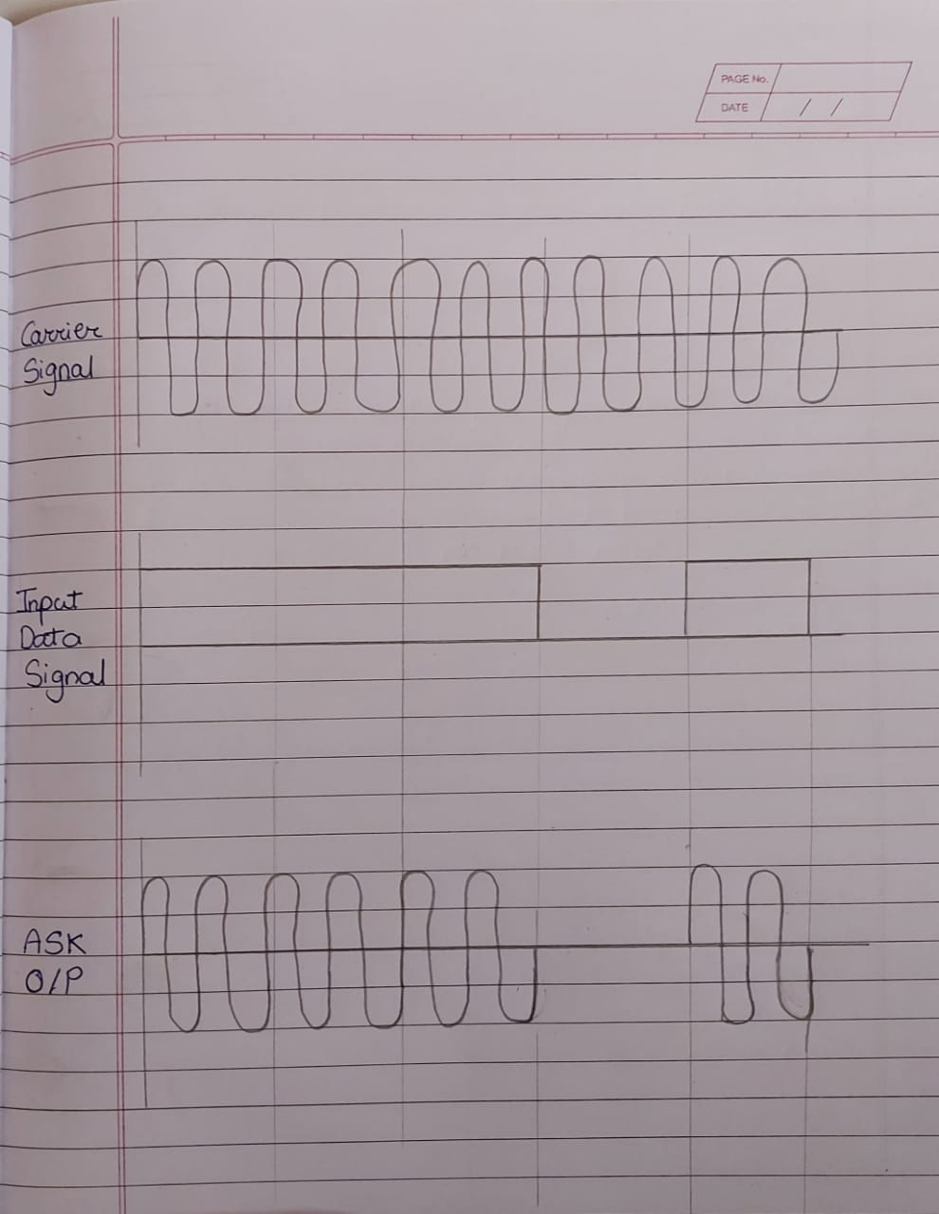Observe the ASK output for bit stream 1110100

* **Exercise**

1. Observe Waveforms at various stages of ASK.

Ans-

|  |  |  |  |  |  |
| --- | --- | --- | --- | --- | --- |
| **Grade and Dated Signature of Teacher** | **C (4M)** | **P (4M)** | **A (2M)** | **Total ( 10 M)** | **Dated Sign** |
|  |  |  |  |  |

